H.T No
Regulations:
A22

Sreenidhi Institute of Science and Technology
(An Autonomous Institution)
Code No:9BC01 Date: 16-January-2025 (FN)

B.Tech I-Year I- Semester External Examination, January-2025 (Regular & Supplementary)
ENGINEERING GRAPHICS ( CE,EEE,MECH,ECE,ECM,AIML & IOT)

Time: 3 Hours Max.Marks:60

Note: a) No additional answer sheets will be provided.
b) All sub-parts of a question must be answered at one place only, otherwise it will not be valued.
c) Missing data can be assumed suitably.
Bloom's Cognitive Levels of Learning (BCLL)

Remember | L1 | Apply | L3 | Evaluate | L5
Understand | L2 | Analyze | L4 | Create | L6

Part - A Max.Marks: 6x2=12

Answer all QUESTIONS, EACH QUESTION CARRIES 2 MARKS.

 |  | BCLL | CO(s) | Marks
1 | What is eccentricity, and what are its values for different types of conic sections? | L1 | CO1 | [2M]
2 | Mention any two differences between first angle and third angle projection. | L2 | CO2 | [2M]
3 | What are solids of revolution? Give examples. | L1 | CO3 | [2M]
4 | How are the development of pyramids drawn? | L2 | CO4 | [2M]
5 | What are isometric axes? How are they represented? | L1 | CO5 | [2M]
6 | How are isometric projection different than orthographic projections? | L2 | CO6 | [2M]

Part – B Max.Marks: 6x8=48
ANSWER ALL QUESTIONS. EACH QUESTION CARRIES 8 MARKS.

 |  | BCLL | CO(s) | Marks
7. | Construct an Ellipse when the distance of focus from the directrix is equal to 60 mm and eccentricity is 2/3. | L3 | CO1 | [8M]
 | OR
8 | A circle of 40 mm diameter rolls along a straight line without slipping. Draw the curve traced by a point on the circumference, for one complete revolution of the circle. Name the curve. | L4 | CO1 | [8M]
9. | Draw the projections of the following points on the same ground line, keeping the projectors 25mm apart.  a) A, in the H.P. and 30mm behind the V.P.  b) B, 50mm above the H.P. and 35mm in front of the V.P.  c) C, in the V.P. and 40mm above the H.P.  d) D, 25mm above the H.P. and 25mm behind the V.P. | L3 | CO2 | [8M]
 | OR
10 | A Straight-Line AB is 70 mm long and inclined at 30^{O} to H.P. and 40^{O} to V.P. The end A of the line is 25mm above H.P. and 30mm in front of V.P. Draw its projections. | L4 | CO2 | [8M]
11 | A hexagonal plane of side 30 mm has an edge on the HP. The surface is inclined at 45^{O} to the HP and perpendicular to the VP. Draw its projections. | L3 | CO3 | [8M]
 | OR
12 | A Hexagonal prism side of base 30 and height 60 is resting on the HP on one of its edges of the base. The axis of the prism makes 60°with HP. Draw the projections. | L4 | CO3 | [8M]
13 | A hexagonal pyramid of side of base 40 mm and axis height 60 mm, resting with its base on H.P, with an edge of the base parallel to V.P. Draw the development of the lateral surface of the pyramid. | L3 | CO4 | [8M]
 | OR
14 | A square prism, base 40 mm side, axis 70 mm long, has its base on the H.P. and its faces equally inclined to the V.P. It is cut by a plane, perpendicular to the V.P., inclined at 60⁰ to the H.P. and passing through a point to the axis, 55 mm above the base. Draw its front view and sectional top view. | L4 | CO4 | [8M]
15 | Draw the isometric view of a square prism of base side 40 mm and axis 60 mm resting on the HP on the i) on the base with axis perpendicular to HP and ii) axis perpendicular to the VP. | L3 | CO5 | [8M]
 | OR
16 | Draw the isometric projection of a hexagonal pyramid of base side 30 mm and axis 60 mm in the following positions: The pyramid is kept on it base on the (i) HP (ii) VP | L4 | CO5 | [8M]
17 | Figure shows pictorial view of an object. Draw the a) Front view, b) Top view and c) side view (All dimensions are in mm)  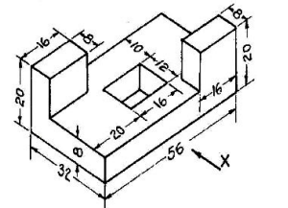 | L4 | CO6 | [8M]
 | OR
18 | Figure shows pictorial view of an object. Draw the a) Front view, b) Top view and c) side view. (All dimensions are in mm)  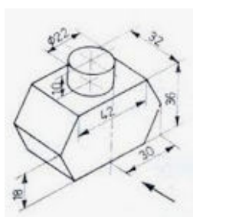 | L4 | CO6 | [8M]

-- 00 -- 00 –

